Lab 2

1. Aim
To study and apply different UV unwrapping techniques in Blender in order to minimize UV stretching and texture distortion on a complex 3D object.

2. Objectives
- To understand UV mapping and stretching.
- To learn seam marking strategies.
- To apply different unwrapping methods.
- To analyse and reduce UV distortion using Blender tools.

3. Software & Requirements
- Software: Blender
- A complex 3D object (e.g., character model, mechanical part, sculpted mesh)
- Texture image for testing (checker texture recommended)

4. Theory
UV Mapping is the process of projecting a 3D model’s surface onto a 2D plane for texturing.
UV Stretching occurs when the texture appears distorted because the 2D UV map does not proportionally represent the 3D surface area.
Stretching usually happens due to:
- Poor seam placement
- Automatic unwrap without planning
- Irregular topology
- High curvature areas
Minimizing distortion ensures textures look natural and consistent.

5. Procedure
Step 1: Prepare the Model
- Open Blender.
- Import or create a complex object.
- Apply transformations:
  - Ctrl + A → Apply All Transforms.
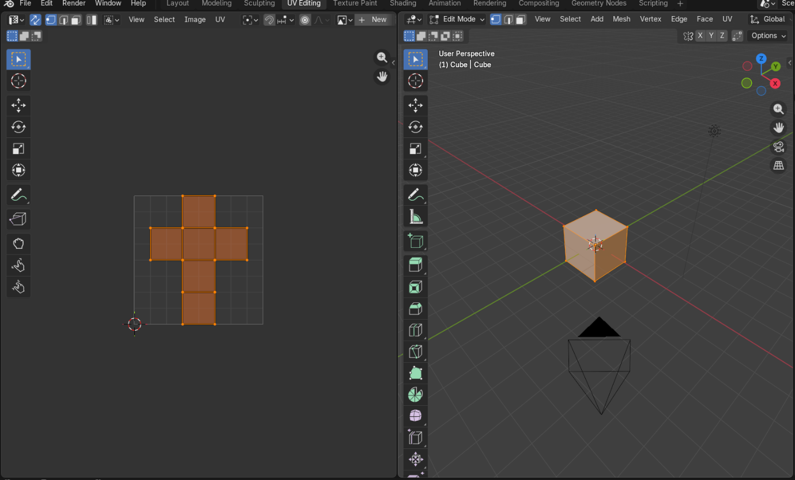

Step 2: Analyse Topology
- Switch to Edit Mode (Tab).
- Check mesh flow and edge loops.
- Identify natural break points (sharp edges, hidden areas).

Step 3: Mark Seams Strategically
Guidelines for Seam Placement:
- Place seams along sharp edges.
- Hide seams in less visible areas.
- Separate cylindrical or curved parts logically.
- Avoid unnecessary seam cuts.
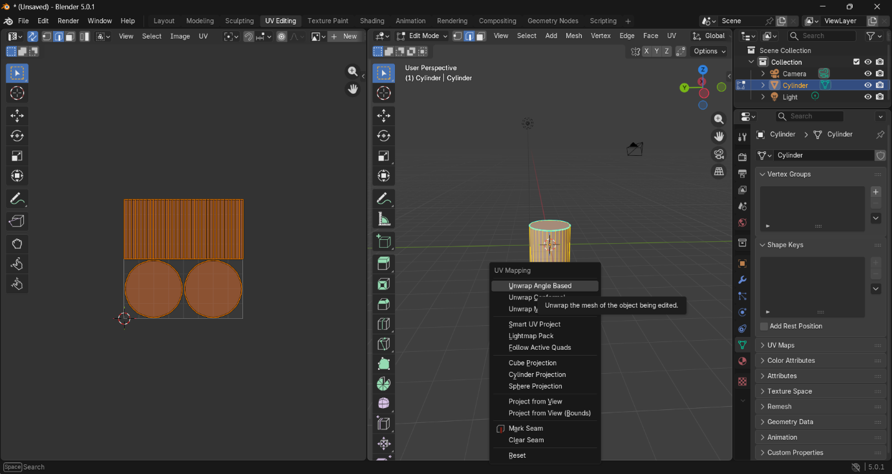
Steps:
- Select edges.
- Press Right Click → Mark Seam.

Step 4: Use Appropriate Unwrapping Methods
1. Unwrap (Best for controlled results)
- Select all faces (A).
- Press U → Choose Unwrap.
This method works best when seams are properly marked.
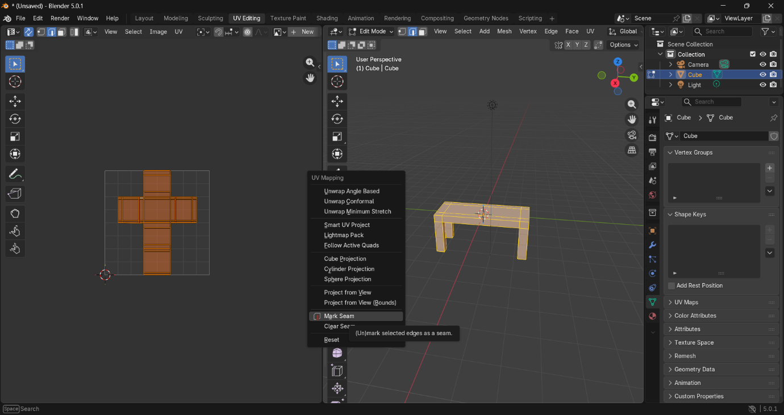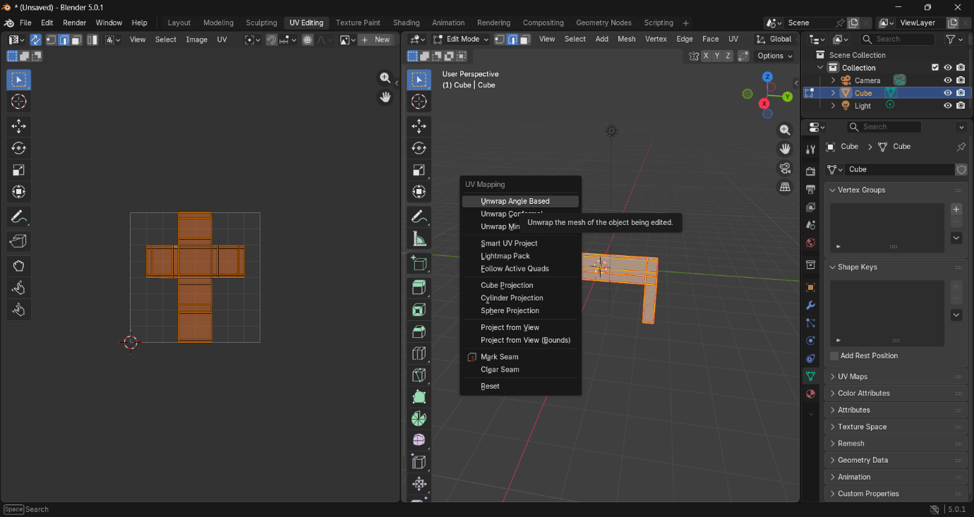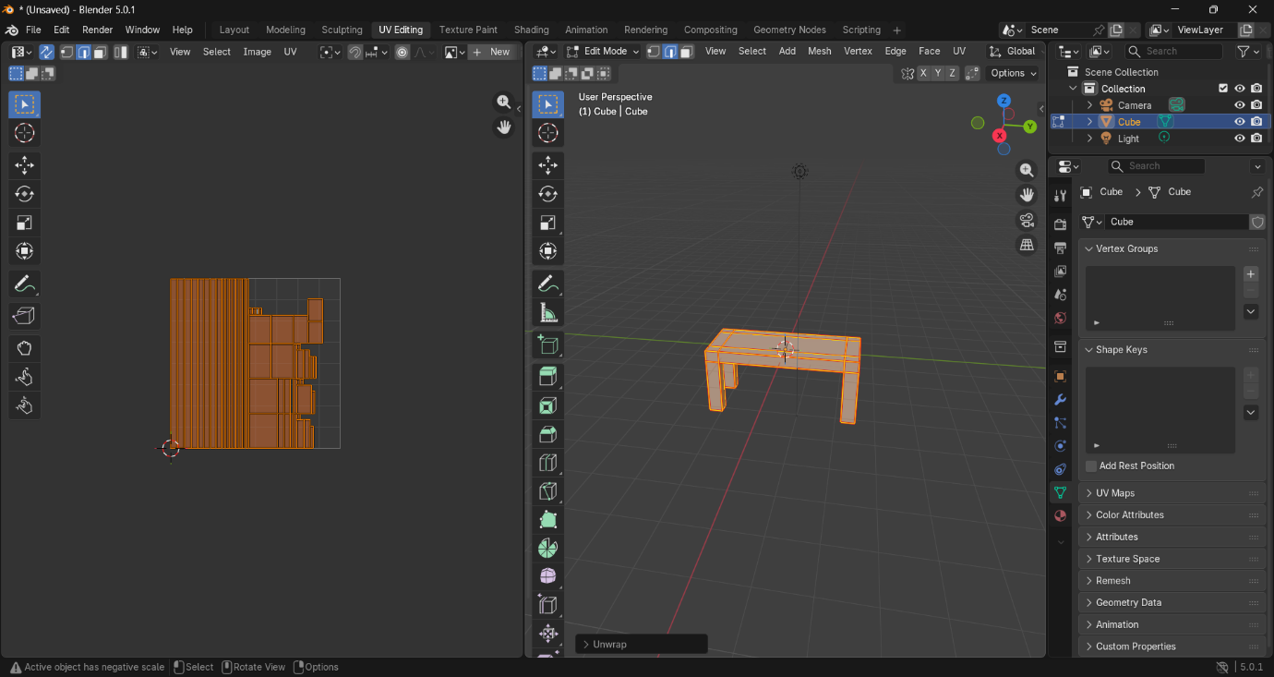

2. Smart UV Project (Quick but less precise)
- U → Smart UV Project.
- Adjust angle limit.
Useful for hard-surface models.

3. Follow Active Quads
Best for quad-based topology with grid flow.

4. Cylindrical / Sphere Projection
Used for round objects.

5: Check for Stretching
- Open UV Editor.
- Apply a checker texture.
- Enable:
  - UV Editor → Overlays → Stretch
Blue Colour: Low distortion
Red Colour: High distortion

6. Observations
- Poor seam placement increases distortion.
- Organic models require more seams than hard-surface models.
- Stretch visualization helps identify problem areas.
- Iterative adjustment improves results significantly.

7. Result
The UV stretching and distortion were successfully minimized using seam optimization, unwrap techniques, stretch visualization, and UV adjustment tools in Blender.

8. Conclusion
Proper seam placement combined with suitable unwrapping methods significantly reduces UV stretching. Visualization tools and iterative correction are essential for achieving clean, distortion-free textures on complex 3D models.

